Controller

## HomeController.cshtml

using System;

using System.Collections.Generic;

using System.Linq;

using System.Web;

using System.Web.Mvc;

using QuizApp.Models;

using System.IO;

namespace QuizApp.Controllers

{

public class HomeController : Controller

{

QuizAPPEntities1 db = new QuizAPPEntities1();

[HttpGet]

public ActionResult Admin_Signup()

{

return View();

}

[HttpPost]

public ActionResult Admin_Signup(Admin_tb snup)

{

if (ModelState.IsValid == true)

{

db.Admin_tb.Add(snup);

int a = db.SaveChanges();

if (a > 0)

{

ViewBag.InsertMessage = "<script>swal('Congradulations', 'Registered Successfully','success')</script>";

ModelState.Clear();

}

else

{

ViewBag.InsertMessage = "<script>alert('Registration Failed!!')</script>";

}

}

return View();

}

[HttpGet]

public ActionResult Admin_login()

{

return View();

}

[HttpPost]

public ActionResult Admin_login(Admin_tb ad)

{

Admin_tb admin = db.Admin_tb.Where(x => x.ADMIN_NAME == ad.ADMIN_NAME && x.ADMIN_PASSWORD == ad.ADMIN_PASSWORD).SingleOrDefault();

if (admin != null)

{

Session["Admin_id"] = admin.ADMIN_ID.ToString();

Session["AdminName"] = admin.ADMIN_NAME;

TempData.Keep();

return RedirectToAction("Dashboard");

}

else

{

ViewBag.msg = "Invalid UserName Or Password!";

}

return View();

}

[HttpGet]

public ActionResult Add_Category()

{

if (Session["Admin_id"]==null)

{

return RedirectToAction("Admin_login");

}

//Session["ad_id"] = 2;//remove it

int Admin_id = Convert.ToInt32(Session["Admin_id"]);

List<CATEGORY> cat = db.CATEGORies.Where(x=>x.CAT_ADMIN_ID == Admin_id).OrderBy(x => x.CAT_ID).ToList();

ViewData["list"] = cat;

return View();

}

[HttpPost]

public ActionResult Add_Category(CATEGORY cat)

{

//----

List<CATEGORY> cat_Li = db.CATEGORies.OrderBy(x => x.CAT_ID).ToList();

ViewData["list"] = cat_Li;

CATEGORY c = new CATEGORY();

Random r = new Random();

c.CAT_NAME = cat.CAT_NAME;

c.CAT_ADMIN_ID = Convert.ToInt32(Session["Admin_id"].ToString());

c.cat_encrypted_string = Crypt.Encrypt(cat.CAT_NAME.Trim() + r.Next().ToString(), true);

db.CATEGORies.Add(c);

Session["catid"] = c.CAT_ID.ToString();

db.SaveChanges();

return RedirectToAction("Add_Category");

}

[HttpGet]

public ActionResult AddQuestions()

{

if (Session["Admin_id"] == null)

{

return RedirectToAction("Admin_login");

}

int sid = Convert.ToInt32(Session["Admin_id"]);

List<CATEGORY> cat_li = db.CATEGORies.Where(x=>x.CAT_ADMIN_ID== sid).ToList();

ViewBag.list = new SelectList(cat_li, "CAT_ID", "CAT_NAME");

List<QUESTION> que = db.QUESTIONS.ToList();

ViewData["que"] = que;

return View();

}

[HttpPost]

public ActionResult AddQuestions(QUESTION q)

{

int aid = Convert.ToInt32(Session["Admin_id"]);

TempData["QUE_ID"] = q.QUE_ID.ToString();

TempData.Keep();

List<CATEGORY> cat_li = db.CATEGORies.Where(x => x.CAT_ADMIN_ID == aid).ToList();

ViewBag.list = new SelectList(cat_li, "CAT_ID", "CAT_NAME");

QUESTION qa = new QUESTION();

qa.QUE_TEXT = q.QUE_TEXT;

qa.OPT_A = q.OPT_A;

qa.OPT_B = q.OPT_B;

qa.OPT_C= q.OPT_C;

qa.OPT_D = q.OPT_D;

qa.CORRECT_OPT = q.CORRECT_OPT;

qa.QUE_CAT_ID = q.QUE_CAT_ID;

db.QUESTIONS.Add(qa);

db.SaveChanges();

ViewBag.msg = "Question Added Successfully";

ModelState.Clear();

return View();

}

[HttpGet]

public ActionResult StudentSignup()

{

return View();

}

[HttpPost]

public ActionResult StudentSignup(STUDENT_TBL st)

{

string filename = Path.GetFileNameWithoutExtension(st.ImageFile.FileName);

string extension = Path.GetExtension(st.ImageFile.FileName);

HttpPostedFileBase postedFile = st.ImageFile;

int length = postedFile.ContentLength;

if (extension.ToLower() == ".jpg" || extension.ToLower() == ".jpeg" || extension.ToLower() == ".png")

{

if (length <= 1000000)

{

filename = filename + extension;

st.STUDENT_IMAGE = "~/Content/Studentimg/" + filename;

filename = Path.Combine(Server.MapPath("~/Content/Studentimg/"),filename);

st.ImageFile.SaveAs(filename);

db.STUDENT_TBL.Add(st);

int a= db.SaveChanges();

if (a>0)

{

TempData["CreateMsg"] = "<script>alert('Registered Successfully.');</script>";

ModelState.Clear();

return RedirectToAction("Student_login","Home");

}

else

{

TempData["CreateMsg"] = "<script>alert('Registration Failed...');</script>";

}

}

else

{

TempData["SizeMsg"] = "<script>alert('Image Size should be less than 1 MB');</script>";

}

}

else

{

TempData["ExtensionMsg"] = "<script>alert('Format Not Supported');</script>";

}

return View();

}

public ActionResult Student_login()

{

return View();

}

[HttpPost]

public ActionResult Student_login(STUDENT_TBL st)

{

STUDENT_TBL student = db.STUDENT_TBL.Where(x => x.STUDENT_NAME == st.STUDENT_NAME && x.STUDENT_PASSWORD == st.STUDENT_PASSWORD).SingleOrDefault();

if (student != null)

{

Session["studentId"] = student.STUDENT_ID.ToString();

return RedirectToAction("ExamDashboard");

}

else

{

ViewBag.msg = "<script>alert('Invalid Name and Password..');</script>";

}

return View();

}

public ActionResult Dashboard()

{

if (Session["Admin_id"] == null)

{

return RedirectToAction("Admin_login");

}

return View();

}

public ActionResult ExamDashboard()

{

if (Session["studentId"] == null)

{

return RedirectToAction("Student_login");

}

return View();

}

[HttpPost]

public ActionResult ExamDashboard(string room)

{

List<CATEGORY> list = db.CATEGORies.ToList();

foreach (var item in list)

{

if (item.cat_encrypted_string==room)

{

List<QUESTION> li = db.QUESTIONS.Where(x => x.QUE_CAT_ID == item.CAT_ID).ToList();

Queue<QUESTION> queue = new Queue<QUESTION>();

foreach (QUESTION a in li)

{

queue.Enqueue(a);

}

TempData["questions"]=queue;

TempData["Score"] = 0;

//TempData["examid"] = item.CAT_ID;

TempData.Keep();

return RedirectToAction("StartQuiz");

}

else

{

ViewBag.error = "<script>alert('No Room Found. Please Enter Correct Room Name....');</script>";

}

}

return View();

}

public ActionResult StartQuiz()

{

if (Session["studentId"]==null)

{

return RedirectToAction("Student_login");

}

QUESTION q = null;

if (TempData["questions"]!=null)

{

Queue<QUESTION> qlist = (Queue<QUESTION>)TempData["questions"];

if (qlist.Count>0)

{

q = qlist.Peek();

qlist.Dequeue();

TempData["questions"] = qlist;

TempData.Keep();

}

else

{

return RedirectToAction("EndExam");

}

}

else

{

return RedirectToAction("ExamDashboard");

}

return View(q);

}

[HttpPost]

public ActionResult StartQuiz(QUESTION q)

{

string correctans = null;

if (q.OPT_A!=null)

{

correctans = "A";

}

else if(q.OPT_B!=null)

{

correctans = "B";

}

else if (q.OPT_C != null)

{

correctans = "C";

}

else if (q.OPT_D != null)

{

correctans = "D";

}

if (correctans.Equals(q.CORRECT_OPT))

{

TempData["Score"] = Convert.ToInt32(TempData["Score"]) + 1;

}

TempData.Keep();

return RedirectToAction("StartQuiz");

}

public ActionResult EndExam()

{

return View();

}

public ActionResult AdminLogout()

{

Session.Abandon();

return RedirectToAction("Index", "Home");

}

public ActionResult Index()

{

return View();

}

public ActionResult About()

{

ViewBag.Message = "Your application description page.";

return View();

}

public ActionResult Contact()

{

ViewBag.Message = "Your contact page.";

return View();

}

}

}

Views

## Admit_Signup.cshtml

@model QuizApp.Models.Admin_tb

@{

ViewBag.Title = "Admin_Signup";

Layout = "~/Views/Shared/_Layout.cshtml";

}

<script src="https://unpkg.com/sweetalert/dist/sweetalert.min.js"></script>

<h2>Admin Sign Up</h2>

@Html.Raw(ViewBag.InsertMessage)

@using (Html.BeginForm())

{

@Html.AntiForgeryToken()

<div class="form-horizontal">

<hr />

@Html.ValidationSummary(true, "", new { @class = "text-danger" })

<div class="form-group">

@Html.LabelFor(model => model.ADMIN_NAME, htmlAttributes: new { @class = "control-label col-md-2" })

<div class="col-md-10">

@Html.EditorFor(model => model.ADMIN_NAME, new { htmlAttributes = new { @class = "form-control" } })

@Html.ValidationMessageFor(model => model.ADMIN_NAME, "", new { @class = "text-danger" })

</div>

</div>

<div class="form-group">

@Html.LabelFor(model => model.Email, htmlAttributes: new { @class = "control-label col-md-2" })

<div class="col-md-10">

@Html.EditorFor(model => model.Email, new { htmlAttributes = new { @class = "form-control" } })

@Html.ValidationMessageFor(model => model.Email, "", new { @class = "text-danger" })

</div>

</div>

<div class="form-group">

@Html.LabelFor(model => model.ADMIN_PASSWORD, htmlAttributes: new { @class = "control-label col-md-2" })

<div class="col-md-10">

@Html.EditorFor(model => model.ADMIN_PASSWORD, new { htmlAttributes = new { @class = "form-control" } })

@Html.ValidationMessageFor(model => model.ADMIN_PASSWORD, "", new { @class = "text-danger" })

</div>

</div>

<div class="form-group">

@Html.LabelFor(model => model.ConfirmPassword, htmlAttributes: new { @class = "control-label col-md-2" })

<div class="col-md-10">

@Html.EditorFor(model => model.ConfirmPassword, new { htmlAttributes = new { @class = "form-control" } })

@Html.ValidationMessageFor(model => model.ConfirmPassword, "", new { @class = "text-danger" })

</div>

</div>

<div class="form-group">

<div class="col-md-offset-2 col-md-10">

<input type="submit" value="Sign Up" class="btn btn-success" />

</div>

</div>

</div>

}

<div>

<a href="@Url.Action("Admin_login","Home")" class="btn btn-primary">If you have Registered already Please LOGIN</a>

</div>

# Admin_Login.cshtml

@model QuizApp.Models.Admin_tb

@{

ViewBag.Title = "Admin_login";

}

<script src="~/Scripts/jquery-3.4.1.min.js"></script>

<script src="~/Scripts/jquery.validate.min.js"></script>

<script>

$(document).ready(function () {

$("#left-div").animate({ width: '30%' }, 900);

$("#teacherimg").animate({ height: '450', width: '320', }, 900);

$("#login_card").animate({ width: '70%', height: '450px' }, 900);

});

</script>

<style>

#teacherimg{

margin-top:20px;

}

.invalid-error {

font-family: 'Lucida Sans', 'Lucida Sans Regular', 'Lucida Grande', 'Lucida Sans Unicode', Geneva, Verdana, sans-serif;

}

</style>

<div class="col-lg-6 col-md-6 col-sm-6" id="left-div" style="width:50%; float:left;">

<img src="~/Content/img/Teacher.png" id="teacherimg" height="500" width="400" alt="Teacher image" />

</div>

<div class="card text-info mb-3 col-lg-6 col-md-6 col-sm-6" id="login_card" style=" width: 5px; height:5px; float: right; background-color: #fffffc; margin-top: 3%; border: 1px solid #fffffc; border-radius: 10px; box-shadow: 4px 4px 15px -2px rgba(0,0,0,0.78) ";>

<div class="card-body">

<div>

<center>

<p class="invalid-error" style="color:red; margin-left:5px;">@ViewBag.msg</p>

</center>

<center>

<div>

<img src="~/Content/img/logincard.png" alt="login image" width="200" height="200" />

</div>

</center>

@using (Html.BeginForm())

{

@Html.AntiForgeryToken()

<div class="form-horizontal">

<center> <h4> Please Login your Account</h4></center>

<hr />

@Html.ValidationSummary(true, "", new { @class = "text-danger" })

<div class="form-group">

@Html.LabelFor(model => model.ADMIN_NAME, htmlAttributes: new { @class = "control-label col-md-4" })

<div class="col-md-8">

@Html.EditorFor(model => model.ADMIN_NAME, new { htmlAttributes = new { @class = "form-control" } })

@Html.ValidationMessageFor(model => model.ADMIN_NAME, "", new { @class = "text-danger" })

</div>

</div>

<div class="form-group">

@Html.LabelFor(model => model.ADMIN_PASSWORD, htmlAttributes: new { @class = "control-label col-md-4" })

<div class="col-md-8">

@Html.EditorFor(model => model.ADMIN_PASSWORD, new { htmlAttributes = new { @class = "form-control" } })

@Html.ValidationMessageFor(model => model.ADMIN_PASSWORD, "", new { @class = "text-danger" })

</div>

</div>

<div class="form-group">

<div class="col-md-offset-4 col-md-8">

<input type="submit" value="Login" class="btn btn-info" />

</div>

</div>

</div>

}

</div>

<br />

<a href="@Url.Action("Admin_Signup","Home")" class="btn btn-primary" style="margin-top:2px;">Go to Registration</a>

</div>

</div>

@section Scripts {

@Scripts.Render("~/bundles/jqueryval")

}

# StudentSignup.cshtml

@model QuizApp.Models.STUDENT_TBL

@{

ViewBag.Title = "StudentSignup";

Layout = "~/Views/Shared/_Layout.cshtml";

}

<h2>StudentSignup</h2>

@Html.Raw(TempData["CreateMsg"])

@Html.Raw(TempData["SizeMsg"])

@Html.Raw(TempData["ExtensionMsg"])

@using (Html.BeginForm("StudentSignup", "Home", FormMethod.Post, new { enctype = "multipart/form-data" }))

{

@Html.AntiForgeryToken()

<div class="form-horizontal">

<hr />

@Html.ValidationSummary(true, "", new { @class = "text-danger" })

<div class="form-group">

@Html.LabelFor(model => model.STUDENT_NAME, htmlAttributes: new { @class = "control-label col-md-2" })

<div class="col-md-10">

@Html.EditorFor(model => model.STUDENT_NAME, new { htmlAttributes = new { @class = "form-control" } })

@Html.ValidationMessageFor(model => model.STUDENT_NAME, "", new { @class = "text-danger" })

</div>

</div>

<div class="form-group">

@Html.LabelFor(model => model.StudentEmail, htmlAttributes: new { @class = "control-label col-md-2" })

<div class="col-md-10">

@Html.EditorFor(model => model.StudentEmail, new { htmlAttributes = new { @class = "form-control" } })

@Html.ValidationMessageFor(model => model.StudentEmail, "", new { @class = "text-danger" })

</div>

</div>

<div class="form-group">

@Html.LabelFor(model => model.STUDENT_IMAGE, htmlAttributes: new { @class = "control-label col-md-2" })

<div class="col-md-10">

<input type="file" name="ImageFile" class="form-control btn btn-primary" required />

@Html.ValidationMessageFor(model => model.STUDENT_IMAGE, "", new { @class = "text-danger" })

</div>

</div>

<div class="form-group">

@Html.LabelFor(model => model.STUDENT_PASSWORD, htmlAttributes: new { @class = "control-label col-md-2" })

<div class="col-md-10">

@Html.EditorFor(model => model.STUDENT_PASSWORD, new { htmlAttributes = new { @class = "form-control" } })

@Html.ValidationMessageFor(model => model.STUDENT_PASSWORD, "", new { @class = "text-danger" })

</div>

</div>

<div class="form-group">

@Html.LabelFor(model => model.ConfirmPassword, htmlAttributes: new { @class = "control-label col-md-2" })

<div class="col-md-10">

@Html.EditorFor(model => model.ConfirmPassword, new { htmlAttributes = new { @class = "form-control" } })

@Html.ValidationMessageFor(model => model.ConfirmPassword, "", new { @class = "text-danger" })

</div>

</div>

<div class="form-group">

<div class="col-md-offset-2 col-md-10">

<input type="submit" value="Signup" class="btn btn-info" />

</div>

</div>

</div>

}

<div>

@Html.ActionLink("If you have already Registered Please LOGIN", "Student_login")

</div>

# Student_Login.cshtml

@model QuizApp.Models.STUDENT_TBL

@{

ViewBag.Title = "Student_login";

}

<h2 style="color:deepskyblue;">Student Log In</h2>

@Html.Raw(ViewBag.msg);

<div>

@using (Html.BeginForm())

{

@Html.AntiForgeryToken()

<div class="form-horizontal">

<center> <h4> Please Login your Account</h4></center>

<hr />

@Html.ValidationSummary(true, "", new { @class = "text-danger" })

<div class="form-group">

@Html.LabelFor(model => model.STUDENT_NAME, htmlAttributes: new { @class = "control-label col-md-2" })

<div class="col-md-10">

@Html.EditorFor(model => model.STUDENT_NAME, new { htmlAttributes = new { @class = "form-control" } })

@Html.ValidationMessageFor(model => model.STUDENT_NAME, "", new { @class = "text-danger" })

</div>

</div>

<div class="form-group">

@Html.LabelFor(model => model.STUDENT_PASSWORD, htmlAttributes: new { @class = "control-label col-md-2" })

<div class="col-md-10">

@Html.EditorFor(model => model.STUDENT_PASSWORD, new { htmlAttributes = new { @class = "form-control" } })

@Html.ValidationMessageFor(model => model.STUDENT_PASSWORD, "", new { @class = "text-danger" })

</div>

</div>

<div class="form-group">

<div class="col-md-offset-2 col-md-10">

<input type="submit" value="Login" class="btn btn-info" />

</div>

</div>

</div>

}

</div>

@section Scripts {

@Scripts.Render("~/bundles/jqueryval")

}

Models

# Admin Table

//------------------------------------------------------------------------------

// <auto-generated>

// This code was generated from a template.

//

// Manual changes to this file may cause unexpected behavior in your application.

// Manual changes to this file will be overwritten if the code is regenerated.

// </auto-generated>

//------------------------------------------------------------------------------

using System.ComponentModel.DataAnnotations;

namespace QuizApp.Models

{

using System;

using System.Collections.Generic;

public partial class Admin_tb

{

[System.Diagnostics.CodeAnalysis.SuppressMessage("Microsoft.Usage", "CA2214:DoNotCallOverridableMethodsInConstructors")]

public Admin_tb()

{

this.CATEGORies = new HashSet<CATEGORY>();

}

public int ADMIN_ID { get; set; }

[Required(ErrorMessage ="Admin Name is Required")]

[Display(Name ="Admin Name")]

public string ADMIN_NAME { get; set; }

[Required(ErrorMessage = "Admin Password is Required")]

[Display(Name = "Admin Password")]

[DataType(DataType.Password)]

public string ADMIN_PASSWORD { get; set; }

[Required(ErrorMessage = "Confirm Password is Required")]

[Display(Name = "Confirm Password")]

[DataType(DataType.Password)]

public string ConfirmPassword { get; set; }

[Required(ErrorMessage = "Admin Email is Required")]

[Display(Name = "Email")]

[DataType(DataType.EmailAddress, ErrorMessage ="Email is not Valid")]

[RegularExpression("^[a-zA-Z0-9_\\.-]+@([a-zA-Z0-9-]+\\.)+[a-zA-Z]{2,6}$", ErrorMessage = "E-mail is not valid")]

public string Email { get; set; }

[System.Diagnostics.CodeAnalysis.SuppressMessage("Microsoft.Usage", "CA2227:CollectionPropertiesShouldBeReadOnly")]

public virtual ICollection<CATEGORY> CATEGORies { get; set; }

}

}

# Subject Category Table

//------------------------------------------------------------------------------

// <auto-generated>

// This code was generated from a template.

//

// Manual changes to this file may cause unexpected behavior in your application.

// Manual changes to this file will be overwritten if the code is regenerated.

// </auto-generated>

//------------------------------------------------------------------------------

using System.ComponentModel.DataAnnotations;

namespace QuizApp.Models

{

using System;

using System.Collections.Generic;

public partial class CATEGORY

{

[System.Diagnostics.CodeAnalysis.SuppressMessage("Microsoft.Usage", "CA2214:DoNotCallOverridableMethodsInConstructors")]

public CATEGORY()

{

this.QUESTIONS = new HashSet<QUESTION>();

}

public int CAT_ID { get; set; }

[Required(ErrorMessage = "Admin Name is Required")]

[Display(Name = "Subject")]

public string CAT_NAME { get; set; }

public Nullable<int> CAT_ADMIN_ID { get; set; }

public string cat_encrypted_string { get; set; }

public virtual Admin_tb Admin_tb { get; set; }

[System.Diagnostics.CodeAnalysis.SuppressMessage("Microsoft.Usage", "CA2227:CollectionPropertiesShouldBeReadOnly")]

public virtual ICollection<QUESTION> QUESTIONS { get; set; }

}

}

# Questions Table

//------------------------------------------------------------------------------

// <auto-generated>

// This code was generated from a template.

//

// Manual changes to this file may cause unexpected behavior in your application.

// Manual changes to this file will be overwritten if the code is regenerated.

// </auto-generated>

//------------------------------------------------------------------------------

using System.ComponentModel.DataAnnotations;

namespace QuizApp.Models

{

using System;

using System.Collections.Generic;

public partial class QUESTION

{

public int QUE_ID { get; set; }

[Required]

[Display(Name = "Question")]

public string QUE_TEXT { get; set; }

[Required]

[Display(Name = "A")]

public string OPT_A { get; set; }

[Required]

[Display(Name = "B")]

public string OPT_B { get; set; }

[Required]

[Display(Name = "C")]

public string OPT_C { get; set; }

[Required]

[Display(Name = "D")]

public string OPT_D { get; set; }

[Required]

[Display(Name = "Correct Option")]

public string CORRECT_OPT { get; set; }

[Required]

[Display(Name = "Subject Category")]

public Nullable<int> QUE_CAT_ID { get; set; }

public virtual CATEGORY CATEGORY { get; set; }

}

}

# Student Table

//------------------------------------------------------------------------------

// <auto-generated>

// This code was generated from a template.

//

// Manual changes to this file may cause unexpected behavior in your application.

// Manual changes to this file will be overwritten if the code is regenerated.

// </auto-generated>

//------------------------------------------------------------------------------

namespace QuizApp.Models

{

using System;

using System.Collections.Generic;

using System.Web;

using System.ComponentModel.DataAnnotations;

public partial class STUDENT_TBL

{

[System.Diagnostics.CodeAnalysis.SuppressMessage("Microsoft.Usage", "CA2214:DoNotCallOverridableMethodsInConstructors")]

public STUDENT_TBL()

{

this.SET_EXAM = new HashSet<SET_EXAM>();

}

public int STUDENT_ID { get; set; }

[Required(ErrorMessage = "Student Name is Required")]

[Display(Name = "Student Name")]

public string STUDENT_NAME { get; set; }

[Required(ErrorMessage = "Student Password is Required")]

[Display(Name = "Student Password")]

[DataType(DataType.Password)]

public string STUDENT_PASSWORD { get; set; }

[Required(ErrorMessage = "Student image is Required")]

[Display(Name = "Student Image")]

public string STUDENT_IMAGE { get; set; }

[Required(ErrorMessage = "Student Email is Required")]

[Display(Name = "Email")]

[DataType(DataType.EmailAddress, ErrorMessage = "Email is not Valid")]

[RegularExpression("^[a-zA-Z0-9_\\.-]+@([a-zA-Z0-9-]+\\.)+[a-zA-Z]{2,6}$", ErrorMessage = "E-mail is not valid")]

public string StudentEmail { get; set; }

[Required(ErrorMessage = "Confirm Password is Required")]

[Display(Name = "Confirm Password")]

[DataType(DataType.Password)]

public string ConfirmPassword { get; set; }

public HttpPostedFileBase ImageFile { get; set; }

[System.Diagnostics.CodeAnalysis.SuppressMessage("Microsoft.Usage", "CA2227:CollectionPropertiesShouldBeReadOnly")]

public virtual ICollection<SET_EXAM> SET_EXAM { get; set; }

}

}

Output ScreenShots

# Screenshots

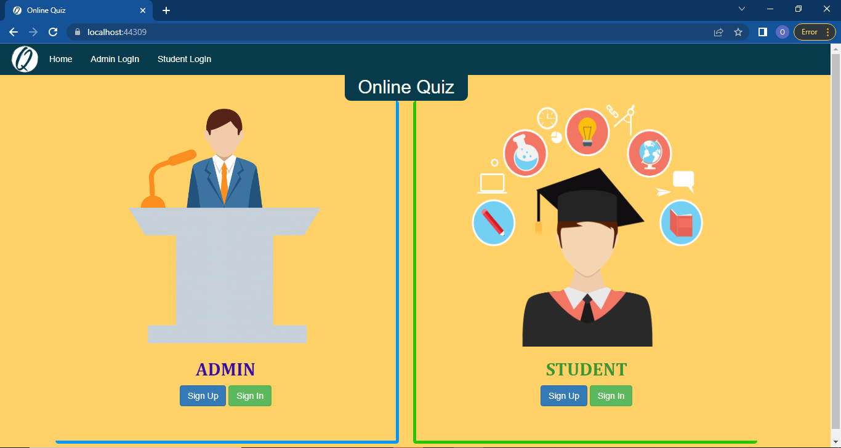

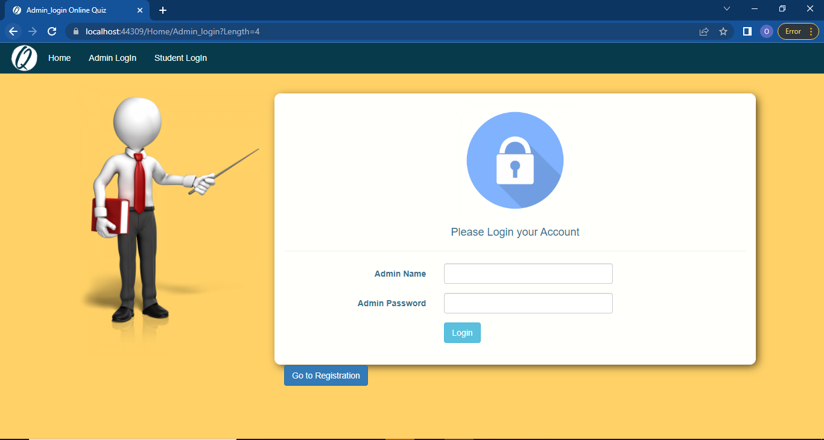

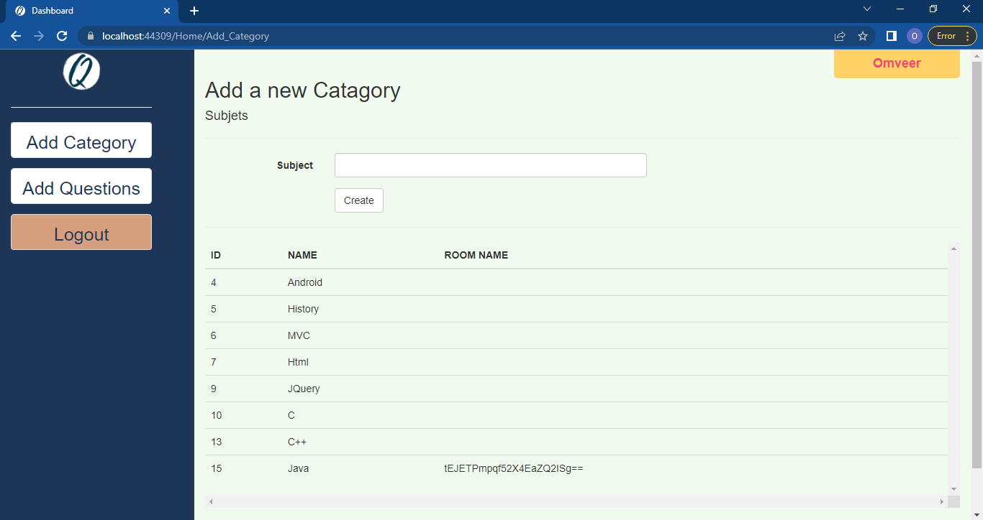

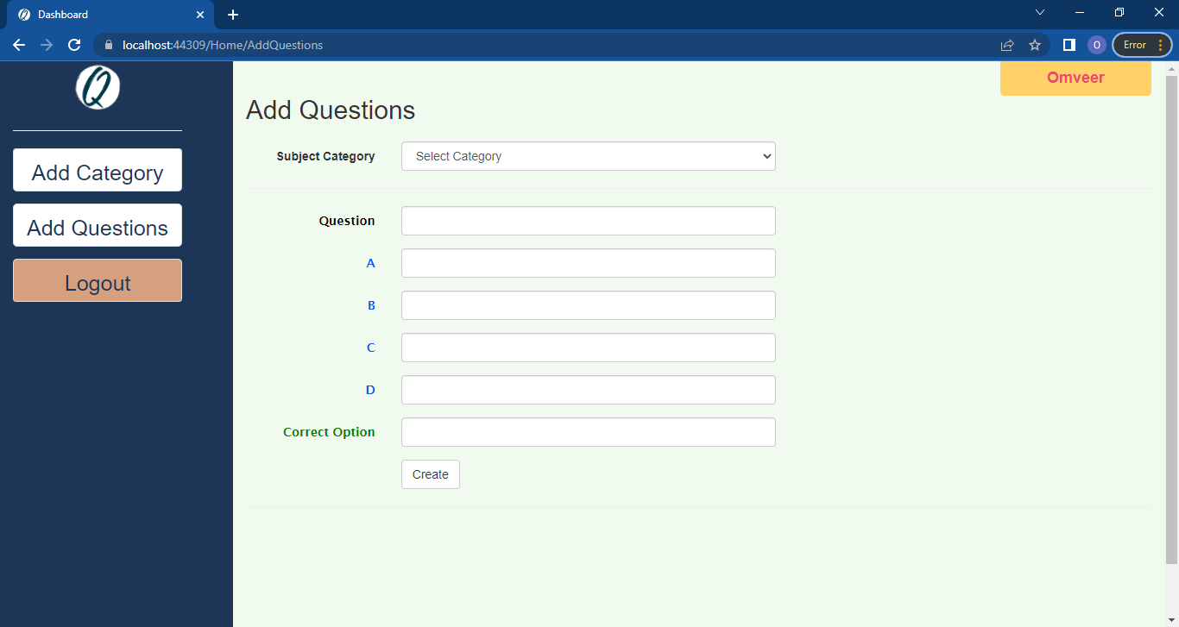

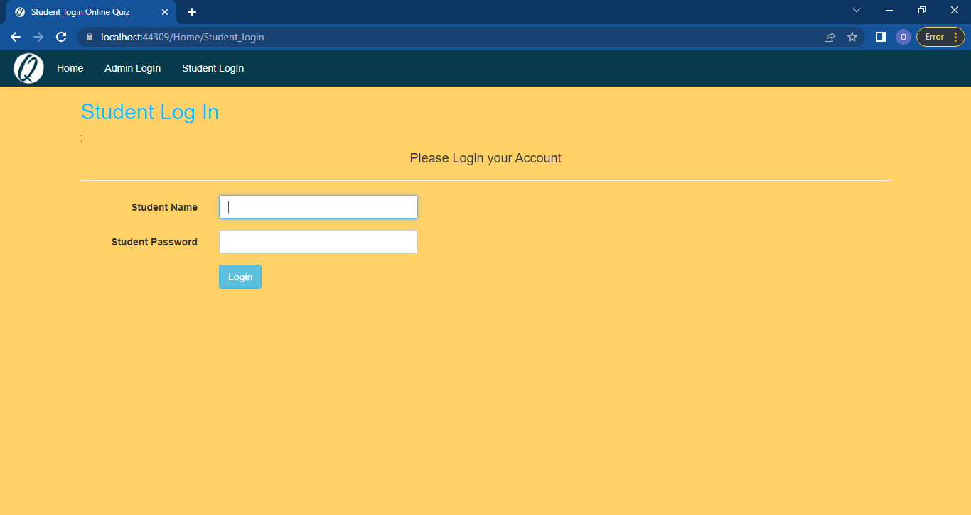

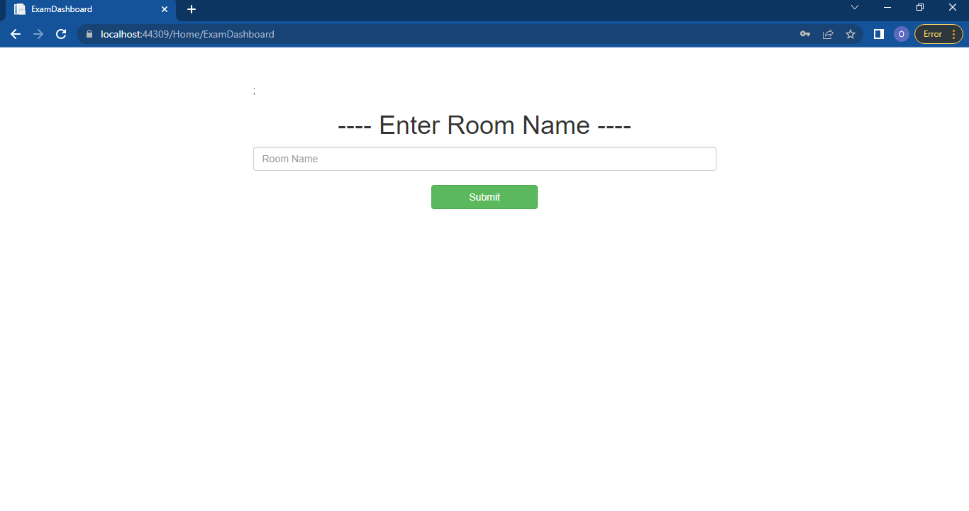

Project Folders

# Folders

